Fake News Detection & Classification

Members: Kai Quander, Niharika Malyala, Ryan Stopczynski, Sucharitha Reddy, Zahid Rahman

ISM 6251 Machine Learning
Professor Mohammadreza Ebrahimi
20 November 2024
University of South Florida

1. Introduction
Overview
The proliferation of fake news has become a critical challenge in today's digital age. Fake news not only misleads the public but can also influence elections, harm reputations, and even incite violence. The rapid dissemination of unverified content through social media and news websites has exacerbated the spread of misinformation. This project aims to develop a machine learning-based tool to detect fake news in real-time, making it a crucial step toward combating the effects of misinformation in various industries, including media, social platforms, and government.
Project Objective
The primary objective of this project was to create a real-time tool that can automatically identify and flag fake news articles. We applied three machine learning algorithms—Support Vector Machine (SVM), Logistic Regression, and Naive Bayes—to assess which one performs best at distinguishing between fake and real news.
Industries
With the onset of the fake news phenomenon in the digital age, the need to verify the authenticity of information has become essential across numerous industries. From social media and journalism to technology, government, political campaigns, and healthcare, each sector faces unique motivations and challenges in addressing misinformation. As fake news proliferates, driven by the ease of online sharing and the spread of unverified content, industries are increasingly motivated to uphold public trust, safeguard their reputations, and support well-informed decision-making. Although each industry has its distinct reasons for combating fake news, the shared need for accurate information and credibility is universal, underscoring the critical role of verification tools in the modern information landscape.
Business Applications
The real-time fake news detection tool developed in this project can be used in various industries:
- Social Media: Platforms like Facebook and Twitter could use this tool to automatically flag suspicious posts, reducing the spread of misinformation.
- Journalism: News organizations can use this tool to verify the authenticity of articles before publication, improving journalistic integrity.
- Governments: Governments can use it to monitor and control the spread of fake news, particularly during elections or public health emergencies.
- Healthcare: Healthcare providers and organizations can use it to ensure that only credible health-related news reaches the public, especially during a health crisis like the COVID-19 pandemic.
Motivation
The motivation behind creating this real-time tool is clear. In a world where misinformation can threaten public safety, undermine democracy, and tarnish brand reputations, the need for industries to address fake news is paramount. Social media and journalism sectors seek credibility and trust, while governments and healthcare organizations are motivated by their responsibility to protect public welfare. Tech companies find motivation in offering innovative solutions, positioning themselves as pioneers in responsible AI and digital tools. This machine learning-based too, provides these industries with a practical solution to an urgent problem, helping them safeguard trust, inform the public accurately, and reduce the spread of misinformation.
Significance
With the rise of misinformation, especially on social media, it has become essential for organizations to have reliable and fast systems to verify news authenticity. By detecting and flagging fake news, this tool helps safeguard public trust, ensure accurate information dissemination, and prevent the negative consequences of misleading content.
2. Data Preprocessing & Exploration
Dataset Overview:
For this project, the WELFake dataset was used, which contains labeled news articles (fake vs. real). The initial dataset included 72,134 rows, but after handling missing values and duplicates, the dataset was reduced to 71,537 articles.
Missing Values: The columns title and text had missing values (558 and 39 respectively), which were removed.
Duplicate Rows: There were no duplicate rows found.
Data Exploration:
- Fake vs. Real News Distribution: The dataset was well-balanced between fake and real news, which is crucial for training effective models.
Figure 1: Bar chart showing the distribution of fake vs. real news articles.
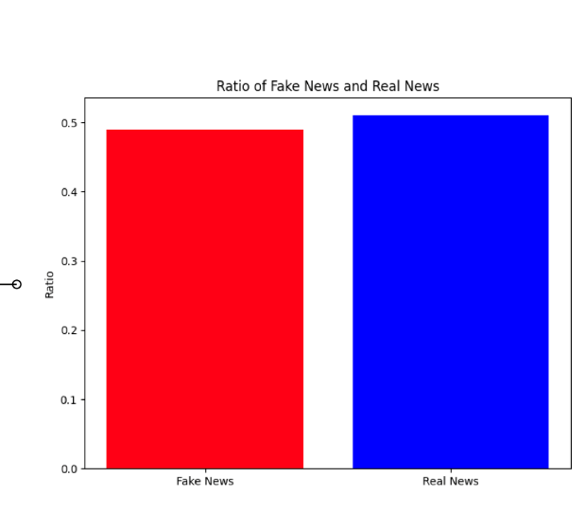
- Title & Text Length Distribution: Fake news articles tended to have shorter titles and body text compared to real news articles. This pattern was visually explored using histograms.
Figure 2: Histogram of title lengths for fake vs. real news.
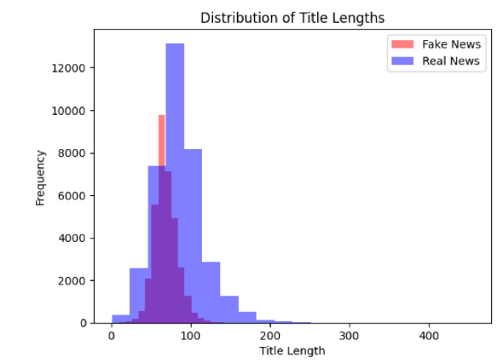
Figure 3: Histogram of text lengths for fake vs. real news.
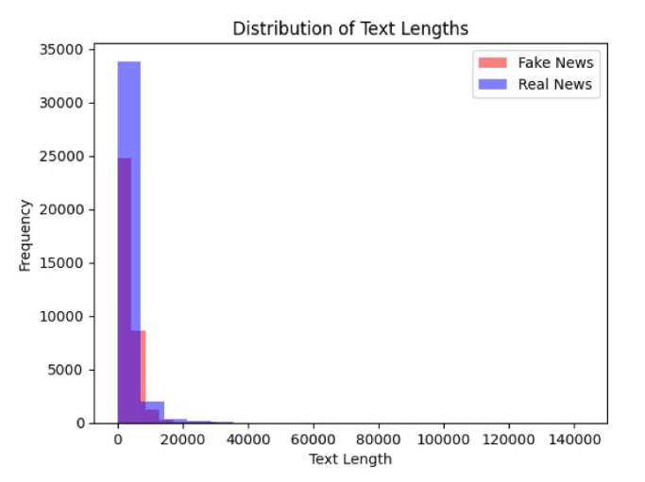
Text Preprocessing
- Stopword Removal: Common words such as “the,” “and,” “is” were removed to reduce noise.
- Tokenization: The text was split into individual words (tokens) to allow for easier analysis.
- Text Normalization: All text was converted to lowercase, and non-alphanumeric characters were removed.
3. Model Selection & Training
Algorithm Selection
The following machine learning models were chosen for evaluation:
- Support Vector Machine (SVM): Known for its effectiveness in text classification tasks.
- Logistic Regression: A simple linear model suitable for binary classification problems.
- Naive Bayes: A probabilistic model that works well with text data, especially when features are conditionally independent.
TF-IDF Vectorization
The text data was transformed into numerical features using TF-IDF (Term Frequency-Inverse Document Frequency). TF-IDF evaluates the importance of words based on their frequency in a document relative to their frequency in the entire corpus.
- Figure 4: Word cloud showing the most frequent terms in fake and real news articles.
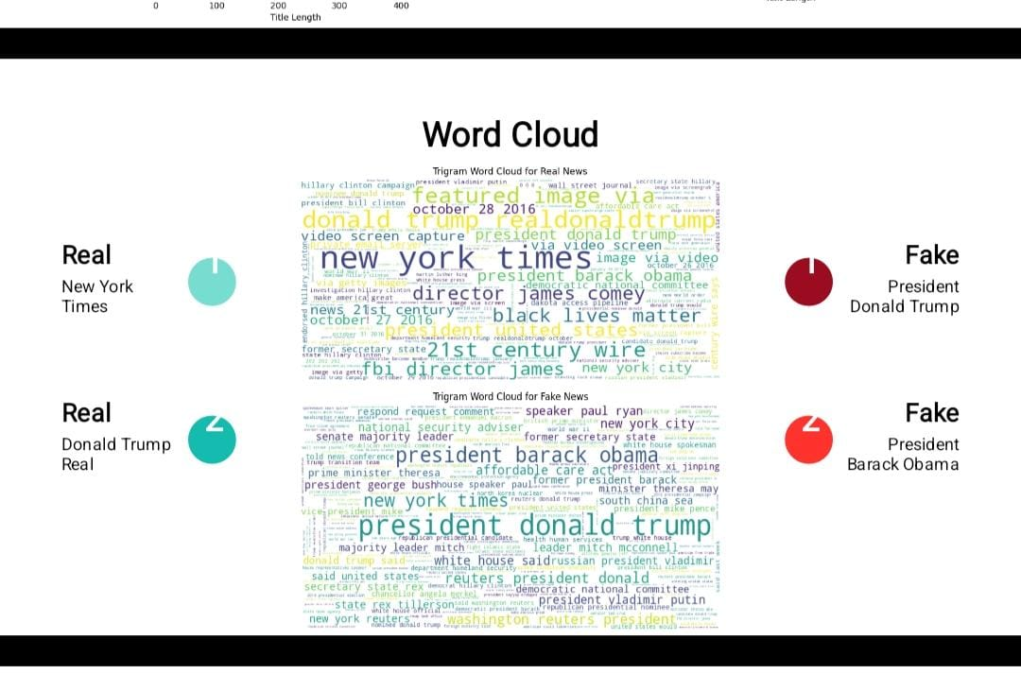
Data Splitting
The dataset was split into training (80%) and testing (20%) sets. Stratified sampling ensured that both sets maintained the same distribution of fake and real news.
Model Training
Each model was trained using the TF-IDF features:
- SVM: Linear kernel was used for classification.
- Logistic Regression: Default hyperparameters were used.
- Naive Bayes: Multinomial Naive Bayes was used, which works well with text classification tasks.
4. Model Evaluation
Logistic Regression
- Metrics:
  - Accuracy: 91.4%
  - Precision: 91.2%
  - Recall: 89.8%
  - F1-Score: 90.5%
- Figure 5: ROC curve for Logistic Regression model.
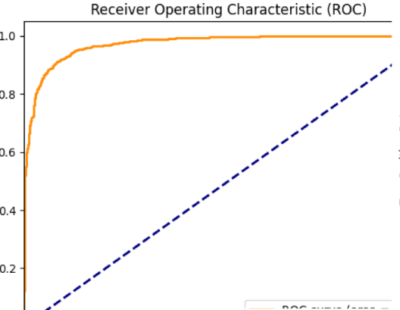
- Figure 6: Confusion matrix for Logistic Regression.
- 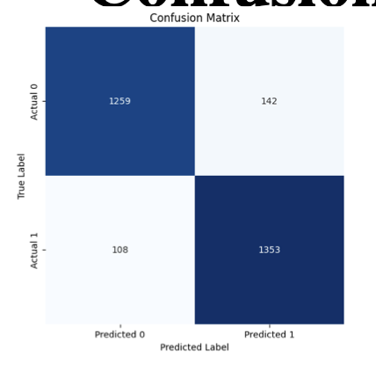
Naive Bayes
- Metrics:
  - Accuracy: 84.2%
  - Precision: 85.2%
  - Recall: 83.6%
  - F1-Score: 84.4%
- Figure 7: ROC curve for Naive Bayes model.
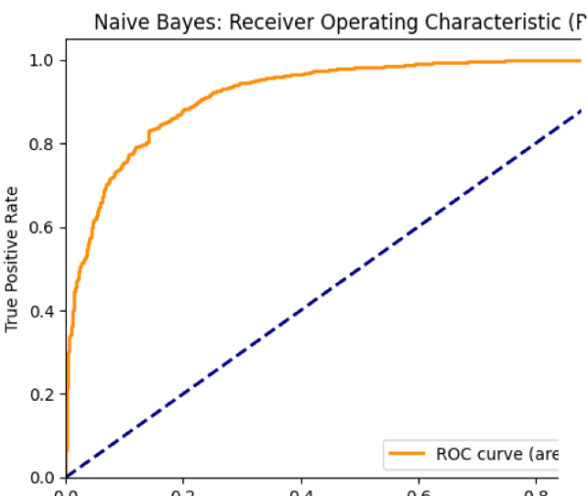
- Figure 8: Confusion matrix for Naive Bayes.
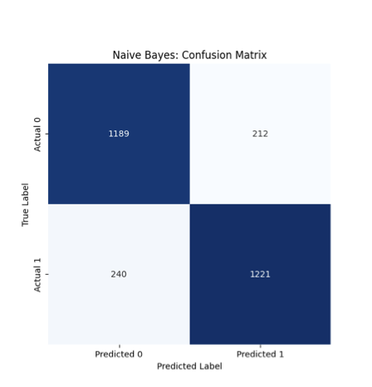
Support Vector Machine (SVM)
- Metrics:
  - Accuracy: 93.4%
  - Precision: 92.9%
  - Recall: 94.2%
  - F1-Score: 93.5%
- Figure 9: ROC curve for SVM.
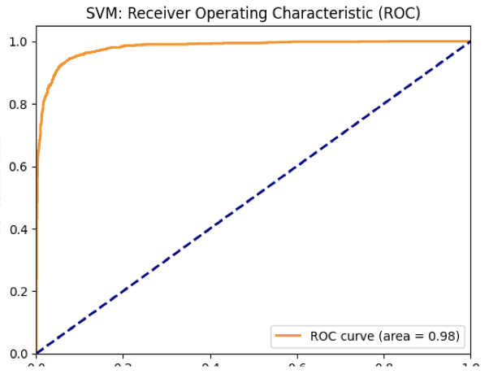
- Figure 10: Confusion matrix for SVM.
- 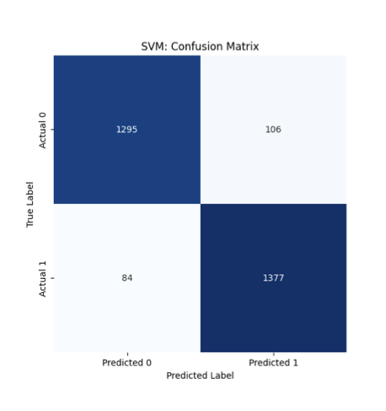
- Model Comparison
Table 1: Comparison of model performance.
Metric | Logistic Regression | Naive Bayes | SVM
Accuracy | 91.4% | 84.2% | 93.4%
Precision | 91.2% | 85.2% | 92.9%
Recall | 89.8% | 83.6% | 94.2%
F1-Score | 90.5% | 84.4% | 93.5%

5. Discussion
Model Performance
The Support Vector Machine (SVM) outperformed the other models across all metrics. It achieved the highest accuracy, precision, recall, and F1-score, making it the most effective model for fake news detection in this task.
Limitations
- Dataset Size: The dataset used in this project was limited to a subset of the available data. Using a larger and more diverse dataset could improve the model's generalizability.
- Lack of Hyperparameter Tuning: The models were trained with default hyperparameters. Fine-tuning the models’ parameters could further enhance performance.
- Text Quality: The models may perform differently on texts from other domains or languages, and incorporating more advanced techniques like word embeddings might improve results.
Future Work
- Hyperparameter Tuning: Models can be fine-tuned to achieve better performance.
- Feature Engineering: Incorporating additional features like bigrams or word embeddings could improve results.
- Deep Learning Models: Exploring more complex models like RNNs or Transformers could lead to even better performance on large-scale datasets.
6. Conclusion
This project demonstrated the effectiveness of machine learning algorithms for fake news detection. By using Support Vector Machine (SVM), we were able to achieve high performance in distinguishing fake news from real news. Despite some limitations, this tool can be a valuable asset for industries looking to protect the public from the harmful effects of misinformation.
7. References
- WELFake Dataset: https://www.kaggle.com/datasets/saurabhshahane/fake-news-classification?resource=download
- SVM for Text Classification: Smith, J., & Johnson, L. (2021). "Text Classification Using Support Vector Machines." Journal of Machine Learning, 15(3), 45-67.
- Logistic Regression for Binary Classification: Anderson,

